Fristly ,I create a database.Then I create two table Department and Instructor.Then insert some value for the two table.The screen shot is given below:

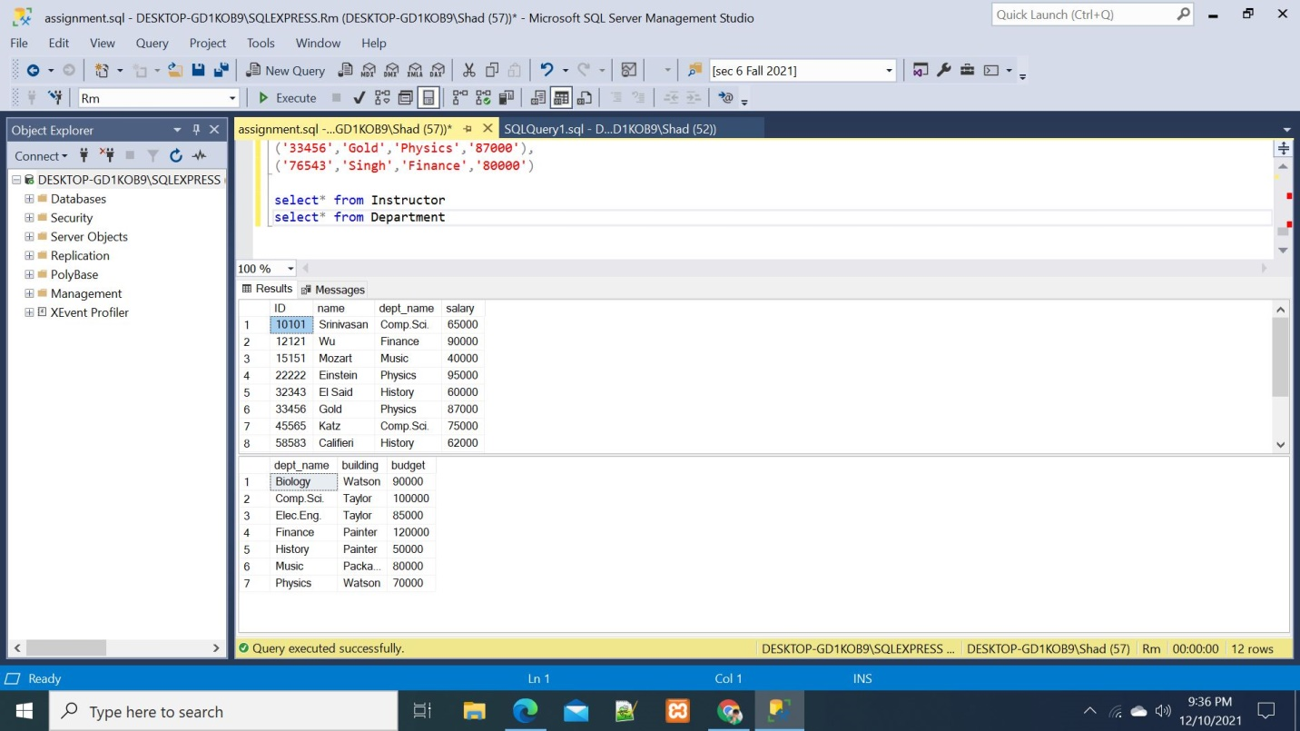

Then, I try to delete and update a value from Department table .But,I can not do it for the foreign key restriction. The screen shot is given below:

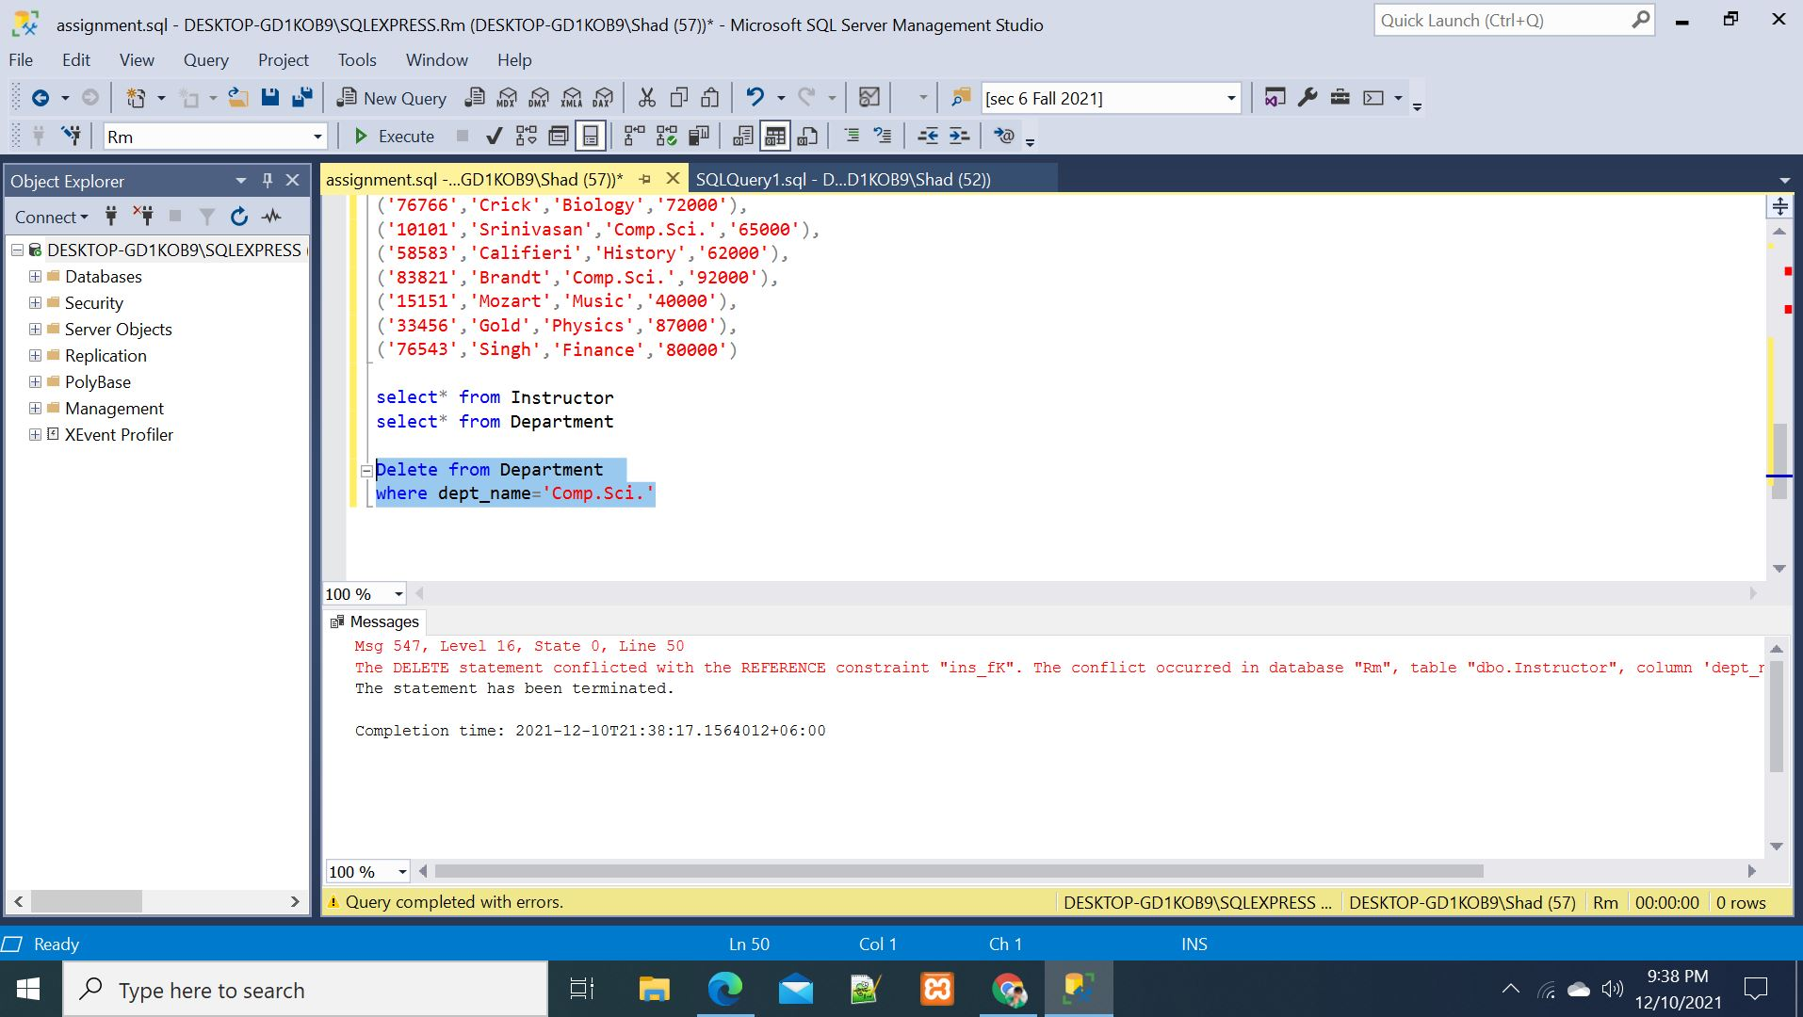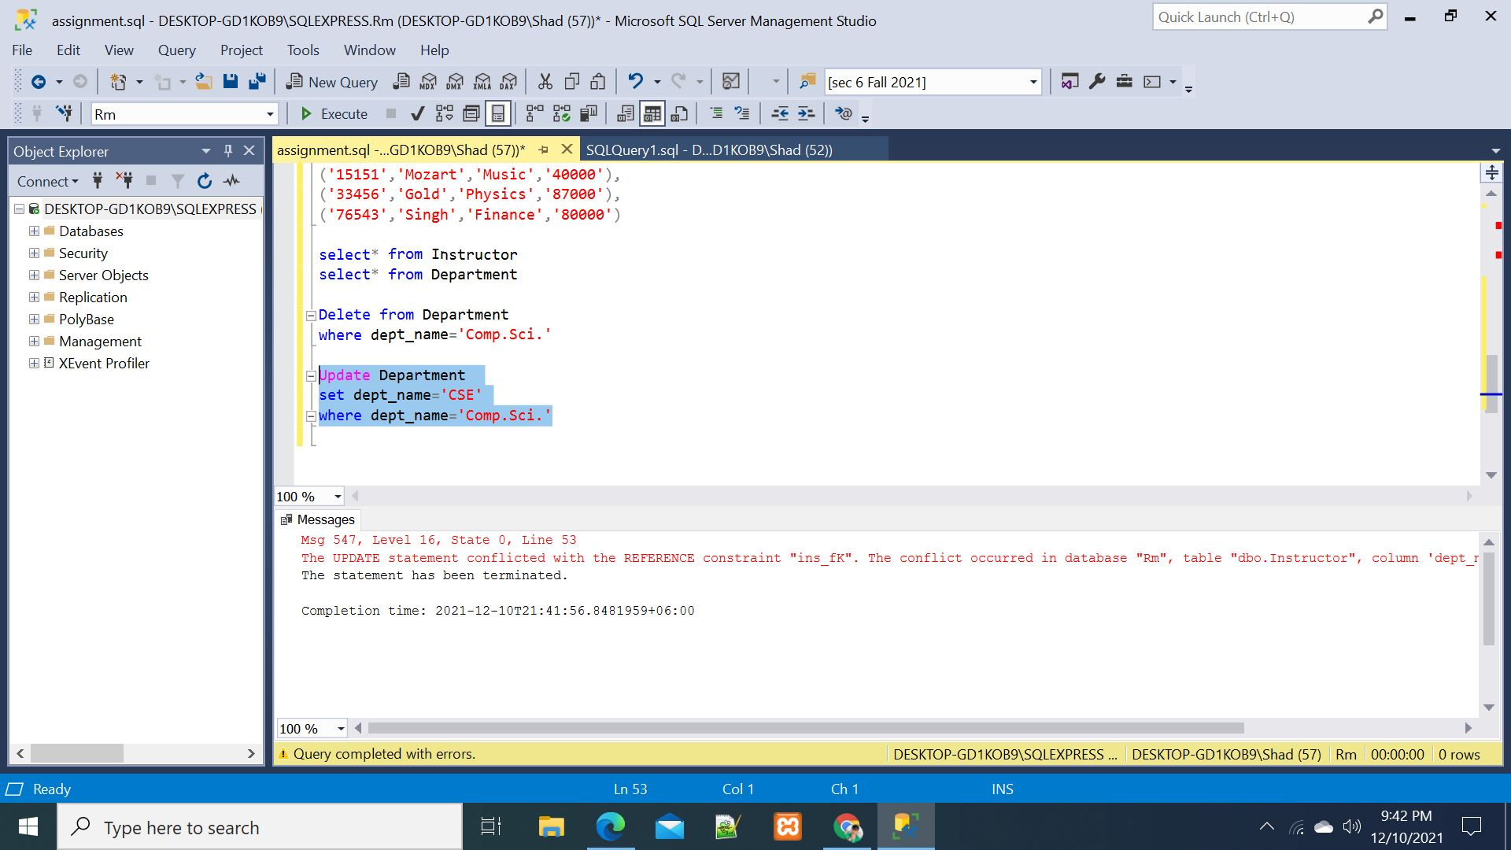

Then,I create another database.Then I create two table Department1 and Instructor1 with delete and update cascade.Then insert some value for the two table.The screen shot is given below:



Then, I try to delete and update a value from Department1 table and I can do the delete and update operation from Department1 table successfully. There was no foreign key restriction because I use delete and update cascade .I delete Biology department and I update ‘com.science’ as ‘CSE’. The screen shot is given below:

**Before delete**



**After Delete**



**Before Update**



**After Update**

